Name | Siddhesh Sonar
UID no. | 2021700063
Experiment No. | 4

AIM: | To implement Longest Common Subsequence
Program
PROBLEM STATEMENT : | To implement Longest Common Subsequence
ALGORITHM/  THEORY: | X and Y be two given sequences  Initialize a table LCS of dimension X.length * Y.length  X.label = X  Y.label = Y  LCS[0][] = 0  LCS[][0] = 0  Start from LCS[1][1]  Compare X[i] and Y[j]  If X[i] = Y[j]  LCS[i][j] = 1 + LCS[i-1, j-1]  Point an arrow to LCS[i][j]  Else  LCS[i][j] = max(LCS[i-1][j], LCS[i][j-1])  Point an arrow to max(LCS[i-1][j], LCS[i][j-1])
PROGRAM: | #include <stdio.h>  #include <string.h>  void printTable(int arr[][20], int len1, int len2)  {  printf("\n");  for(int i = 0 ; i < len1+1 ; i++) {  for(int j = 0 ; j < len2+1 ; j++) {  printf("%d ",arr[i][j]);  }  printf("\n");  }  }  void findLCS(char seq1[], char seq2[])  {  int table[20][20];  int len1 = strlen(seq1);  int len2 = strlen(seq2);  for (int i = 0; i <= len1; i++)  {  table[i][0] = 0;  }  for (int i = 0; i <= len2; i++)  {  table[0][i] = 0;  }  for (int i = 1; i <= len1; i++)  for (int j = 1; j <= len2; j++)  {  if (seq1[i - 1] == seq2[j - 1])  {  table[i][j] = table[i - 1][j - 1] + 1;  }  else if (table[i - 1][j] >= table[i][j - 1])  {  table[i][j] = table[i - 1][j];  }  else  {  table[i][j] = table[i][j - 1];  }  }  int index = table[len1][len2];  char LCS[index + 1];  LCS[index] = '\0';  int i = len1, j = len2;  while (i > 0 && j > 0)  {  if (seq1[i - 1] == seq2[j - 1])  {  LCS[index - 1] = seq1[i - 1];  i--;  j--;  index--;  }  else if (table[i - 1][j] > table[i][j - 1])  i--;  else  j--;  }  printf("seq1 : %s \nseq2 : %s \n", seq1, seq2);  printf("LCS: %s", LCS);  printf("\n\nTable: \n");  printTable(table, len1, len2);  }  int main()  {  char seq1[20], seq2[20];  printf("\nEnter the first sequence: ");  scanf("%s",seq1);  printf("\nEnter the second sequence: ");  scanf("%s",seq2);  // char seq1[20] = "abaaba";  // char seq2[20] = "babbab";  findLCS(seq1,seq2);  printf("\n");  return 0;  }
RESULT:
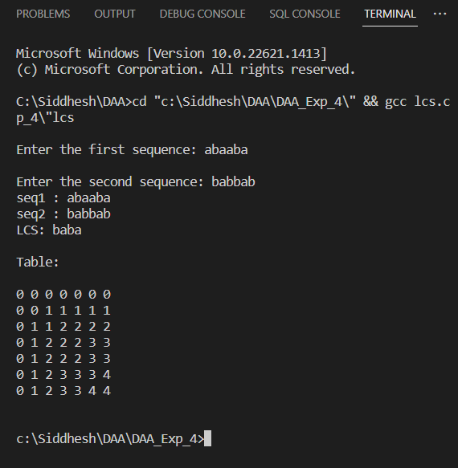
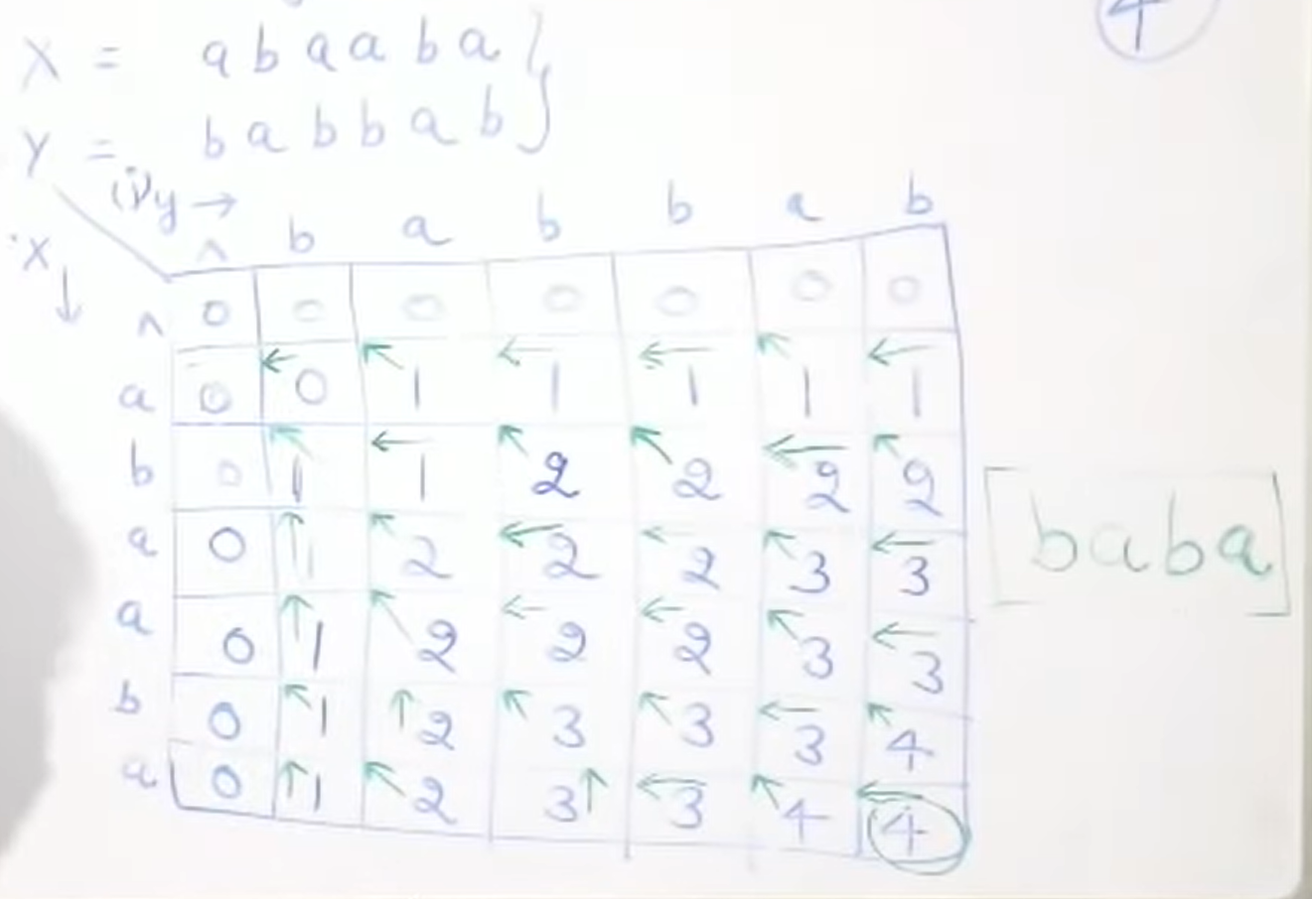
CONCLUSION: | Successfully understood Longest Common Subsequence algorithm and implemented it in C program

